PRESS RELEASE FOR PUBLICATION

Leonberg, 16.10.2017


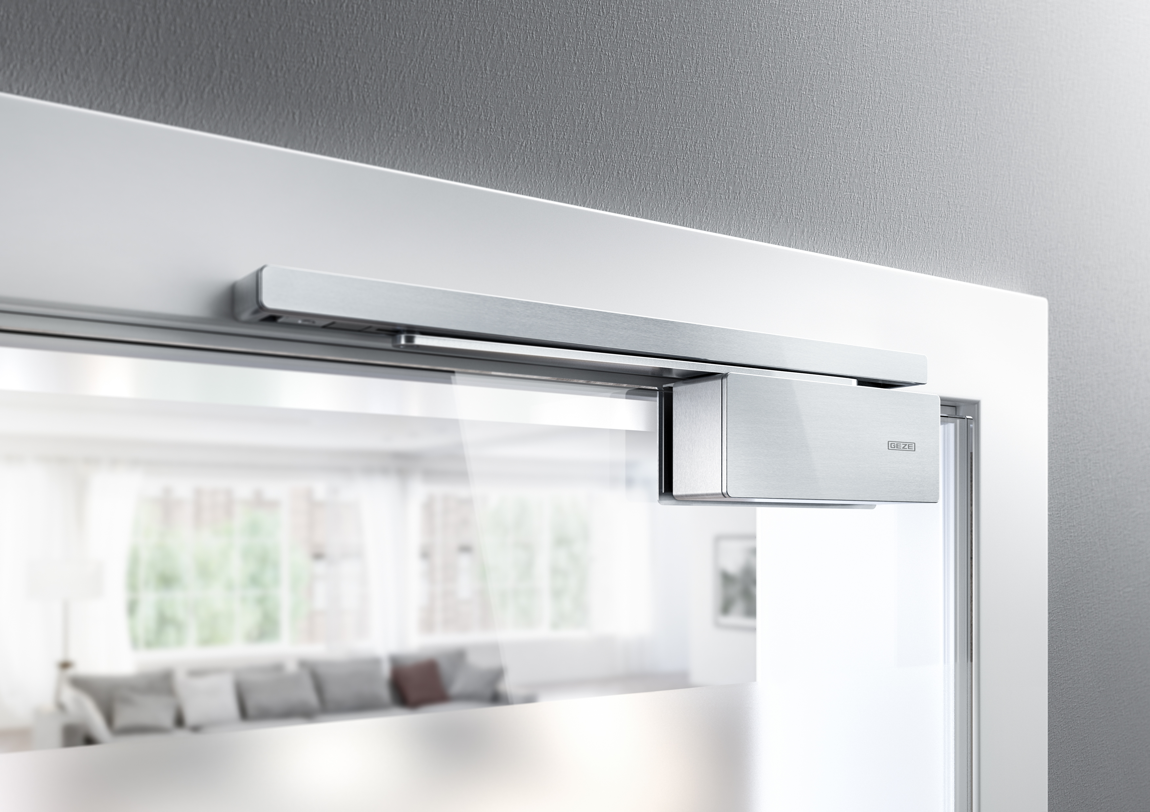
Image: GEZE GmbH
The new GEZE ActiveStop door damper also ensures
new door control in the version fitted on the frame.

FocusOpen in Silver
GEZE ActiveStop once again receives major design award

A further award confirms the design quality of GEZE ActiveStop: having received an award in 2015, the door damper for interior doors has now received the Design-Center Baden-Württemberg FocusOpen 2017 award in Silver for the new version that is fitted on the frame. The product is on display until 22 November 2017 in the associated exhibition in the 'MIK Museum Information Kunst' in Ludwigsburg.

Design quality is at the heart of this prestigious award. The panel recognised the GEZE ActiveStop door damper in the new version fitted on the frame as an innovative product solution with exceptional design quality, and awarded it a top position in the 'Living' category.

GEZE ActiveStop promises innovative convenience for room doors, combined with elegant design. It is easier and more comfortable to enter a room than ever before. The intelligent system ensures controlled, dampened opening and closing of room doors, whether retrofitted as a version fitted on the frame which can be stuck on and easily be removed again, or discreetly integrated in the door leaf. Because thanks to the small integration depth, the door damper for internal doors meets the most stringent of design demands and integrates invisibly in virtually every door leaf.

Gentle stopping –holding open with ease – quiet closing
The intelligent door damper also prevents damage to walls and furniture in the vicinity of the door, and to the door itself. Whether with a gentle or more energetic push – GEZE ActiveStop opens doors independently up to an individually adjustable hold-open position of between 80 and 140 degrees. Doors are halted at the right time and kept open securely in the required position. Thanks to active damping, they close gently and quietly when they reach 25 degrees. GEZE ActiveStop safely holds doors open on its own, without the need for lock latches. Doors run freely at between 25 and 60 degrees. They are halted securely from 25 or from 60 degrees.

Prestigious and traditional design award
The Baden-Württemberg international design award – awarded since 2015 as the FocusOpen – looks back on a long tradition and is highly regarded both at home and abroad. The Design Center Baden Württemberg invites companies and designers worldwide to take part. The 'Focus Silver' award goes to products whose design quality and innovative solutions impress within a category.

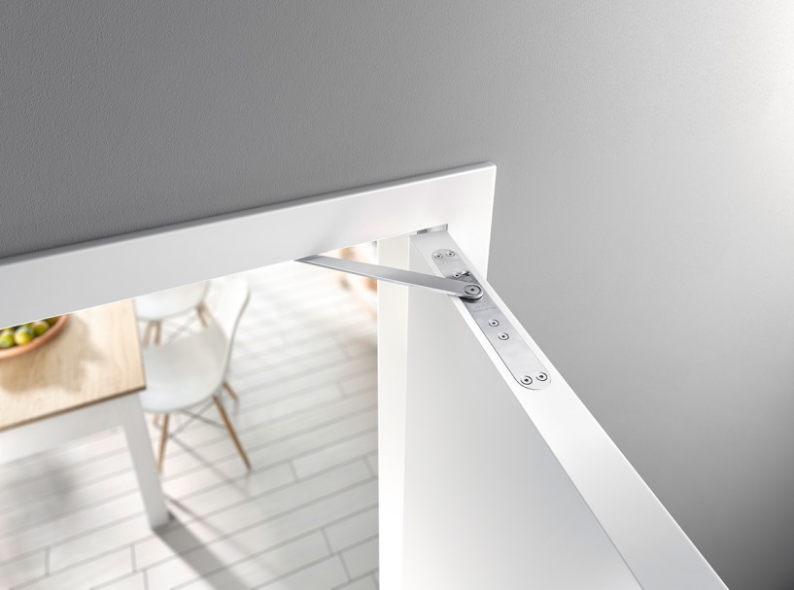

Image: GEZE GmbH

The new GEZE ActiveStop door damper is also
available as a version integrated attractively into the door leaf –
another award-winner.

Press contact:  Julia Graf  Tel.: +49 (0) 7152 203-505  j.graf@geze.com  Fax: +49 (0) 7152 203-237 | GEZE GmbH  Reinhold-Vöster-Str. 21-29  D-71229 Leonberg  www.geze.com

About GEZE
The GEZE brand stands for innovation and for top quality products, processes and services. GEZE is one of the leaders in the global market and it is a reliable partner worldwide for door, window and safety technology products and systems. No matter what the requirements of a building are – GEZE implements optimum solutions and combines functionality and security with comfort and design. GEZE door closers open up numerous technical and visual possibilities. Every day, millions of people go through doors equipped with the overhead door closers from the TS 5000 series and enjoy the comfort of automatic door systems, e.g. the Slimdrive range. Barrier free door and window systems provide greater comfort, not only for people with restricted mobility. The glass systems and fitting solutions for the attractively designed sliding systems are the ultimate in design aesthetics. GEZE also offers a wide product range in the field of window and ventilation technology. Complete "intelligent" smoke and heat extraction solutions (RWA) and a comprehensive selection of door systems for RWA air supply solutions are also available for preventive fire protection. GEZE's safety technology includes escape and rescue route solutions, lock technology, and access control systems. The GEZE building management system provides an overview of a building's entire technical facilities. With its systems expertise, GEZE creates coordinated system solutions which combine individual functional and safety requirements in one intelligent system. GEZE product solutions have received numerous awards and can be found in renowned structures all over the world. The company has a global presence with 31 subsidiaries, 27 of which are outside Germany, a flexible and highly efficient sales and service network, and almost 2,800 employees. In the 2016/2017 fiscal year, GEZE achieved a turnover of over 406 million euros.

